CHAPTER-1

INTRODUCTION
An online blood bank management system is a web-based platform designed to streamline and automate the process of blood donation and donor-recipient matching. It serves as a centralized system where users can register as blood donors, search for donors based on blood group and location, and manage their donation history efficiently.
By digitizing donor records and automating the search process, this system eliminates the inefficiencies of manual blood donation management, ensuring faster response times, accurate donor information, and improved accessibility. With features like real-time donor availability tracking, automated notifications, and secure profile management, this system enhances the overall blood donation experience.
By reducing manual effort and improving data accuracy, the online blood bank management system helps patients find compatible donors quickly, encourages voluntary blood donation, and ensures a more organized approach to blood donation management. This system plays a vital role in bridging the gap between blood donors and recipients, ultimately saving more lives through efficient and accessible blood donation services.

CHAPTER-2
EXISTING SYSTEM AND LITERATURE SURVEY

Existing System
The current blood donation process is largely manual and inefficient, making it difficult to find suitable donors quickly during emergencies. Hospitals and blood banks maintain donor records in separate databases, leading to delays and limited accessibility for those in urgent need.
In the existing system, patients or their families must manually search for donors through hospitals, blood banks, or social media appeals, which is time-consuming and unreliable. There is no centralized platform where users can easily find available donors based on blood group and location. Additionally, donor information is often outdated, and there is no automated tracking of donor eligibility, making it challenging to ensure timely blood availability.
Manual record-keeping in hospitals and blood banks also increases the chances of errors, data loss, and difficulty in updating donor information. Furthermore, there is no proper communication system between donors and recipients, causing delays in the donation process. Due to the lack of real-time donor availability tracking, patients often struggle to find a matching donor when they need it the most.
The inefficiencies in the existing system highlight the need for an online blood bank management system that can automate and streamline the entire blood donation process, ensuring faster and more reliable donor-recipient connections.

Literature Survey

Sl. No. | Title & Authors | Year | Key Contributions & Findings
1 | Online Blood Bank Management Systems: Challenges and Opportunities  Sharma V., Patel A. | 2020 | - Discusses modernization of blood donation through technology.  - Centralized systems reduce manual work and errors.  - Real-time donor search, availability tracking, and reminders.  - Emphasizes security (authentication, encryption).  - Highlights challenges like low awareness and rural gaps.
2 | Cloud-Based Blood Bank Management System  Das K., Iyer P. | 2019 | - Proposes scalable cloud setup for multiple hospitals.  - Enables real-time sync across blood banks.  - Uses platforms like Firebase, AWS Lambda.  - Concerns about vendor lock-in and data security.
3 | Smart Blood Bank Using IoT and Web Technologies  Naidu A., Rao V. | 2020 | - IoT-based tracking of temperature, expiry, volume.  - Real-time alerts through web portals.  - Built using Raspberry Pi, PHP, JavaScript, MySQL.  - High cost and need for technical skills are barriers.
4 | A Review on Blood Donation Management Systems  Kumar S., Yadav N. | 2018 | - Compares global systems on features and usage.  - Encourages open-source tools (Open Blood Bank, Bahmni).  - Suggests awareness and government involvement.  - Highlights need for interoperability and education.

CHAPTER-3
PROBLEM STATEMENT AND OBJECTIVES

Problem Definition/Aim of the Project
The process of finding blood donors in emergencies is often slow and inefficient due to the lack of a centralized system. Traditional methods rely on hospital databases, manual donor lists, and word-of-mouth referrals, making it difficult to locate suitable donors quickly. Additionally, donor information is often outdated, and there is no automated system to track donor availability or notify them about upcoming eligibility.
The aim of this project is to develop an online blood donation system that allows users to register as donors, search for donors based on blood group and state, manage their profiles, and receive notifications about urgent blood requests. The system ensures that only eligible donors are displayed, reducing delays in finding a match.By providing a user-friendly interface, real-time donor availability tracking, and secure data management, this project aims to bridge the gap between blood donors and recipients, promote voluntary blood donation, and make the entire donation process more efficient and accessible.

  - Challenges
    - Real-time donor availability tracking – Keeping donor information updated and ensuring that only eligible donors are displayed in search results.
    - Data security and privacy – Protecting sensitive donor and recipient information from unauthorized access and data breaches.
    - User engagement and participation – Encouraging donors to register, update their availability, and participate actively in blood donation.
    - Ensuring accurate donor information – Preventing fake or incorrect registrations by implementing verification methods.
  - Limitations
    - No guarantee of immediate donor availability – Even if a donor is listed, they may not respond immediately or may be unavailable at the required time.
    - User participation dependency – The system relies on users actively registering, updating their availability, and responding to donation requests.
    - Lack of physical blood storage – Unlike traditional blood banks, the system only facilitates donor-recipient connections and does not store blood for immediate transfusion.
    - Verification of donor information – Ensuring that registered donors provide accurate and legitimate details can be challenging without a strict verification process.

  - Application
- Real-time donor search – Enables users to search for donors by filtering results based on blood type and state.
- Donor registration and management – Allows individuals to register as donors, update their availability status, and manage their profiles.
- Community support and engagement – Helps create a strong network of blood donors who can contribute regularly to save lives.

CHAPTER-4
REQUIREMENTS

Hardware Requirements
      - Processor: Intel Core i5 or equivalent
      - RAM: 8 GB
      - Storage: 512 GB HDD or SSD
      - Internet: Reliable internet connection for real-time donor searches and updates

  - Software Requirements
- Operating System: Windows 10 or higher, macOS, or Linux
- Programming Languages: HTML, CSS, JavaScript, and PHP
- Database: MySQL for storing donor and recipient information
- Web Server: Apache or Nginx for hosting the application
- Frameworks: Bootstrap for responsive design and jQuery for interactive elements

  - Functional Requirements
- User Registration and Authentication:
- Donor and recipient registration with secure login credentials.
- Profile management (update, modify, or delete information).
- Blood Donor Management:
- Stores donor details including blood group, state, and contact information.
- Allows donors to update availability status.

- Blood Search and Filtering:
- Search donors by blood group and state.
- Display only eligible donors based on last donation date.
- Notifications:
- Reminders for donors when they become eligible to donate again.

- Security and Authentication:
- Secure user authentication with encrypted password storage.
- Prevent unauthorized access to donor and recipient data.

Non-Functional Requirements

- Performance Requirements:
- The system should be able to handle at least 500 simultaneous donor searches without affecting performance.
- Response time for searching a donor should be less than 3 seconds.
- Scalability:
- The system should support an increasing number of registered donors and recipients as the platform grows.
- Usability:
- The interface should be simple, intuitive, and user-friendly for users of all backgrounds.
- Security Requirements:
- User authentication should be implemented with secure login and session management.
- All donor and recipient information should be encrypted to prevent unauthorized access.

CHAPTER-5

SYSTEM DESIGN AND METHODOLOGHY

Methodology
The development of an online blood donation system follows a systematic approach to ensure efficiency, reliability, and accessibility. The methodology is based on the Software Development Life Cycle (SDLC), implemented using a modular design to streamline donor registration, search functionalities, and user profile management. The process begins with requirement analysis, where key system functionalities are identified, such as donor registration, user authentication, and real-time donor search. This ensures a well-defined system that meets the needs of both donors and recipients.
Following this, the system design phase involves defining the architecture, designing the database schema, and developing UI/UX prototypes for an intuitive and user-friendly experience. The frontend is built using HTML, CSS, and JavaScript, while the backend is developed using PHP and MySQL for secure data management. Once development is complete, the testing phase ensures that all modules function correctly, verifying real-time donor search, profile management, and security features. The system is then deployed on a web server, making it accessible to users. Regular maintenance and updates are performed to enhance security, improve performance, and ensure a smooth user experience. This structured approach ensures an effective and reliable online blood donation system.

Software Architecture
The online blood donation system follows a three-tier architecture, ensuring scalability, security, and efficiency. It consists of the Presentation Layer (Frontend), Application Layer (Backend), and Database Layer (Data Storage). This structure facilitates smooth communication between users, system processes, and stored data.
The Presentation Layer is responsible for user interaction and is developed using HTML, CSS, JavaScript, and Bootstrap. It provides an intuitive interface where users can register as donors, search for blood donors, update their profiles, and receive notifications. The frontend communicates with the backend via HTTP requests to retrieve and update data.
The Application Layer (Backend) handles core functionalities such as user authentication, donor registration, real-time donor search, and notifications. It is developed using PHP, ensuring secure data processing and smooth communication between the frontend and database. This layer ensures that only eligible donors are displayed, and automated notifications are sent to donors when they become eligible for donation again.
The Database Layer manages all data storage and retrieval processes using MySQL. It stores user profiles, donor details, last donation dates, and search queries. The database ensures data consistency, security, and quick retrieval to facilitate real-time donor availability tracking.

  - Database Design

Donor Table

Stores details of registered blood donors.
- Name
- Gender
- Email
- City
- Date of Birth
- Contact Number
- Blood Group
- Password
- Save Life Date
After this process is complete, the donor will have access to update their profile, search for other donors, and manage their donation history.

  - UI Design
The UI design of the online blood donation system focuses on simplicity, responsiveness, and user-friendliness, ensuring a smooth experience for donors and recipients. The system includes multiple pages, each designed for a specific function.

Home Page
- Displays an introduction to the platform and its purpose.
- Provides buttons for "Register," "Login," and "Search Donors."

Registration Page (Donate page)
- Users enter details such as name, email, phone number, blood group, city, and password.
- A simple form layout ensures easy registration.

Login Page
- Users log in using their email and password.
- A password visibility toggle helps users check their input.

Donor Search Page
- Recipients can search for donors by blood group and state.
- Displays matching donor profiles with contact details.

Profile Page
- Allows users to update personal details, change password, or delete their account.
- Displays eligibility for next donation.

Contact Page
- Provides an option for users to send inquiries or feedback about the system.
.

Module Design
The online blood donation system is divided into different modules to ensure smooth functionality, scalability, and maintainability. Each module handles a specific feature of the system.
- User Registration & Authentication Module
  - Allows users to register, log in, and log out securely.
  - Stores user credentials and ensures authentication.
- Donor Management Module
  - Enables users to register as blood donors by providing personal details, blood group, and location.
  - Allows donors to update, modify, or delete their profiles.
- Blood Donor Search Module
  - Enables recipients to search for donors based on blood group and state.
  - Displays a list of matching donors with contact details (if allowed).
- Profile Management Module
  - Allows users to edit personal details, change availability status, or delete their accounts.
  - Ensures only active and eligible donors are displayed.
- Notification Module
  - Reminds donors when they are eligible to donate again (after 3 months).
- Security & Data Management Module
  - Ensures secure data storage and privacy protection for donor and recipient details.
  - Prevents unauthorized access through authentication mechanisms.

  - ERD Diagram

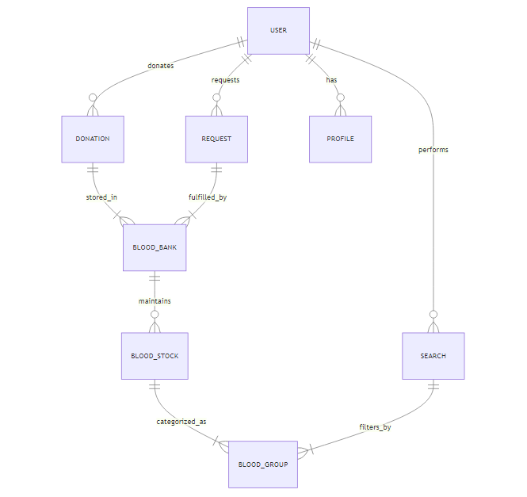

CHAPTER-6

PSUEDOCODE

BEGIN Online_Blood_Bank_Management_System

// User Authentication Module
FUNCTION Login(email, password)
IF Validate_Credentials(email, password) THEN
RETURN "Login Successful"
ELSE
RETURN "Invalid Credentials"
ENDIF
END FUNCTION

FUNCTION Register_User(name, email, password, phone, blood_group, city)
SAVE user details in database
RETURN "User Registered Successfully"
END FUNCTION

// Donor Management Module
FUNCTION Add_Donor(donor_details)
SAVE donor_details in database
RETURN "Donor Added Successfully"
END FUNCTION

FUNCTION Update_Donor_Profile(donor_id, updated_details)
UPDATE donor profile in database
RETURN "Profile Updated Successfully"
END FUNCTION

FUNCTION Delete_Donor_Profile(donor_id)
DELETE donor profile from database
RETURN "Profile Deleted Successfully"
END FUNCTION

// Blood Donor Search Module
FUNCTION Search_Donor(blood_group, state)
FETCH donors WHERE blood_group AND state MATCH database
IF donors found THEN
RETURN list of donors
ELSE
RETURN "No Donors Available"
ENDIF
END FUNCTION

// Notifications Module
FUNCTION Send_Notification(user_id, message)
FETCH user contact details
SEND message via Email/SMS
RETURN "Notification Sent"
END FUNCTION

FUNCTION Donation_Reminder()
FETCH donors eligible for donation (after 3 months)
FOR EACH eligible donor DO
Send_Notification(donor_id, "You are eligible to donate again!")
ENDFOR
END FUNCTION

END Online_Blood_Bank_Management_System

CHAPTER-7

EXPERIMENTS AND RESULTS

- User Registration & Authentication
- Verified that users can sign up by entering their details.
- Checked if users can log in securely using their credentials.
- Ensured authentication prevents unauthorized access.

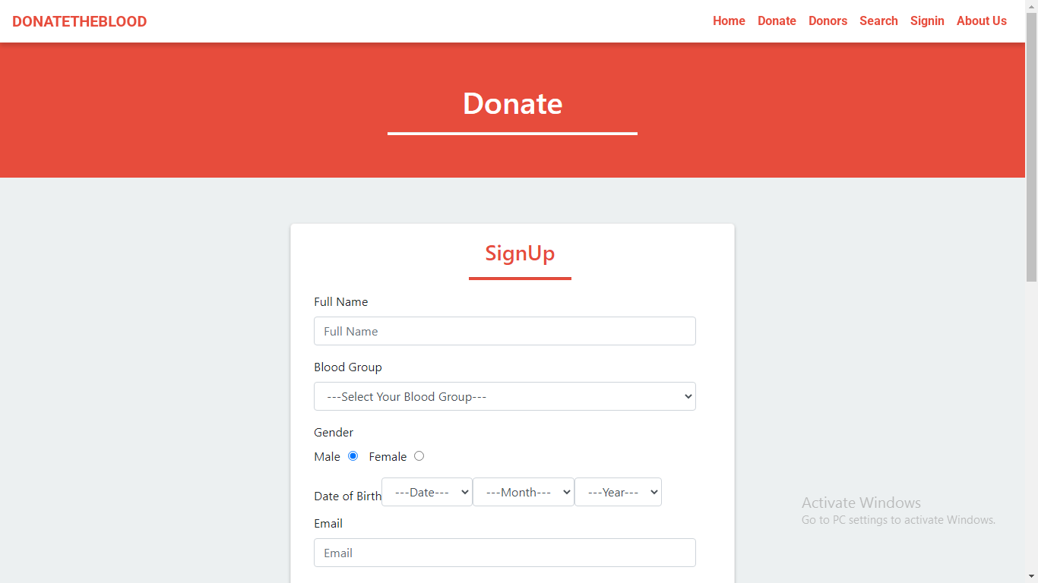
User Registration Page

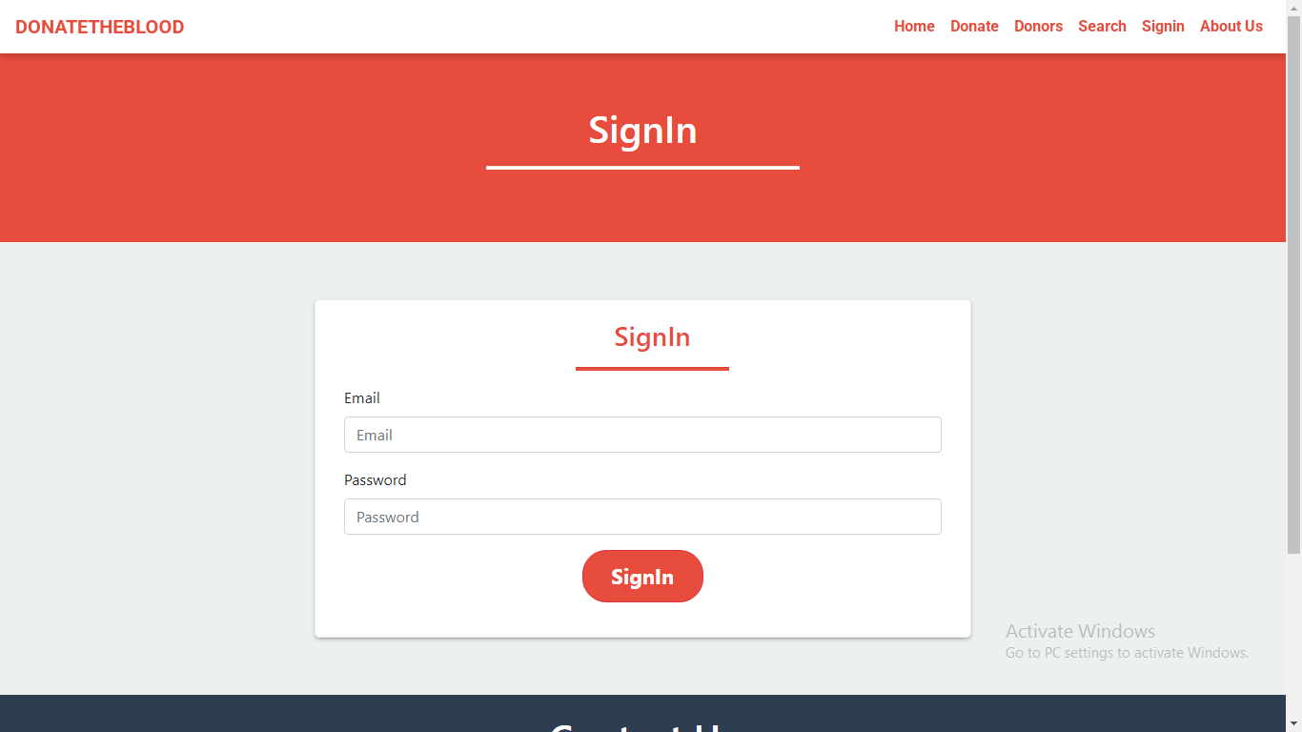
User Log-in

- Donor Management
- Tested profile creation, updating, and deletion.
- Checked if donors can search for blood groups and filter results by location.
- Verified that donation status is updated correctly.
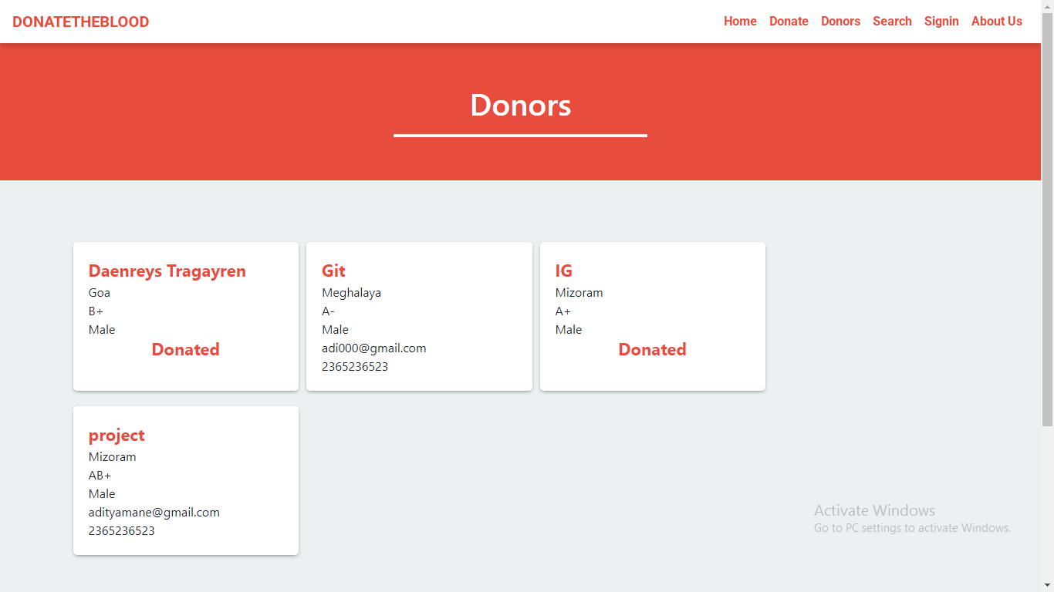
Donors

- Blood Donor Search
- Ensured users can search for donors based on blood group and state.
- Checked that results display accurate donor information.

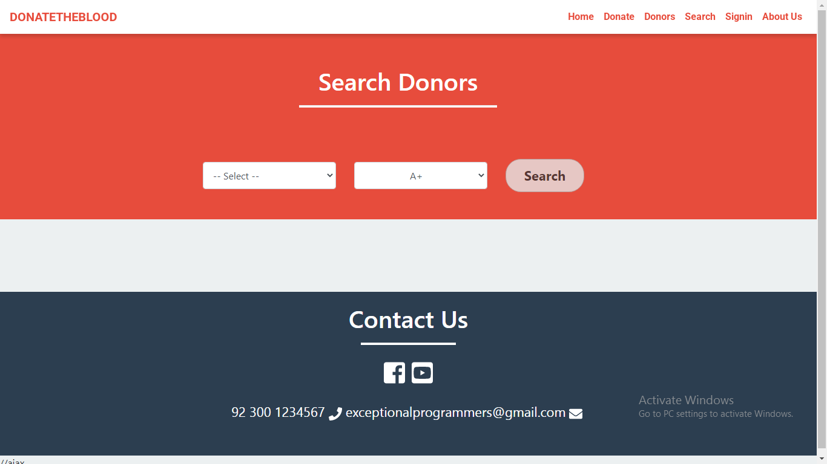

Result:
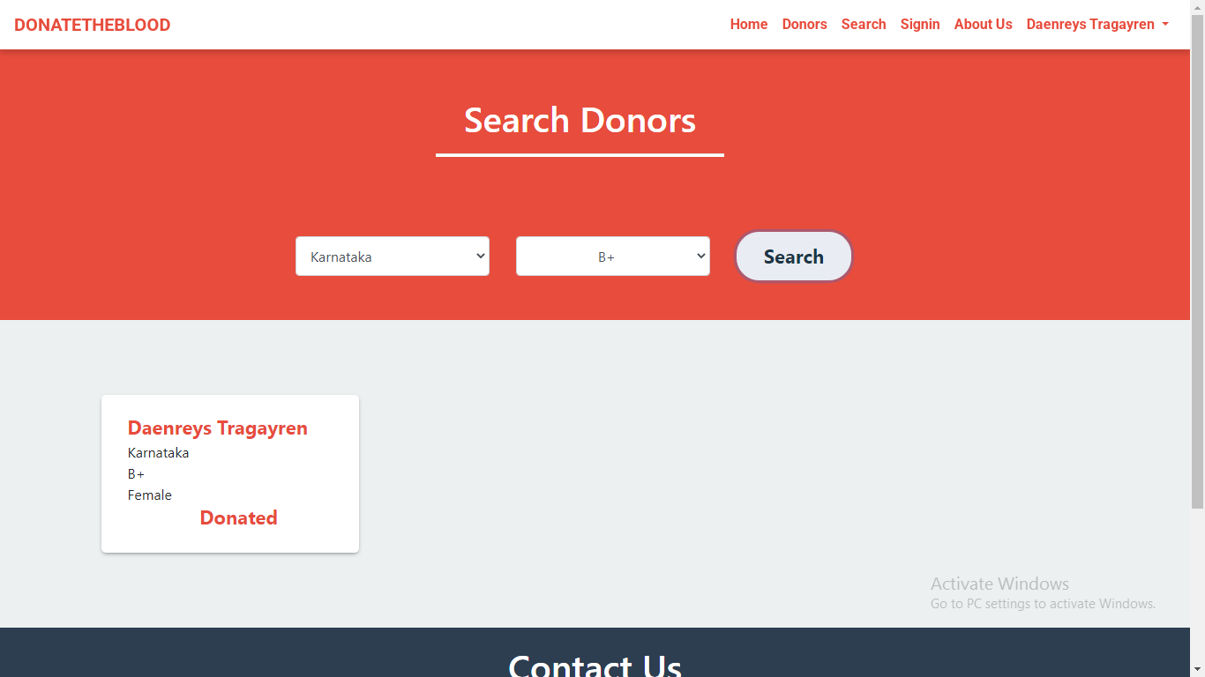

- Profile Management
- Users can update their personal information (name, email, blood group, location, etc.).
- Users have the option to delete their account permanently.
- All profile updates are saved instantly in the system.

Update Account:
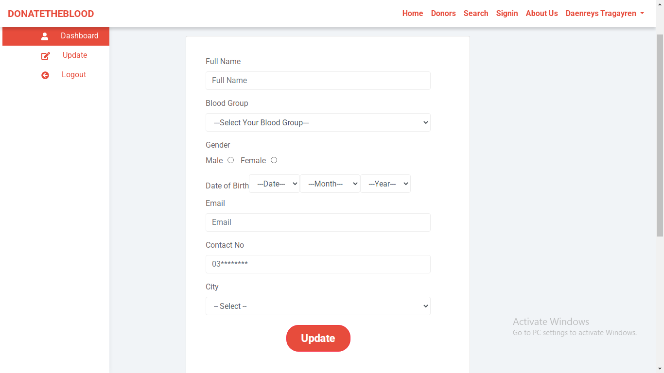

Delete Account:
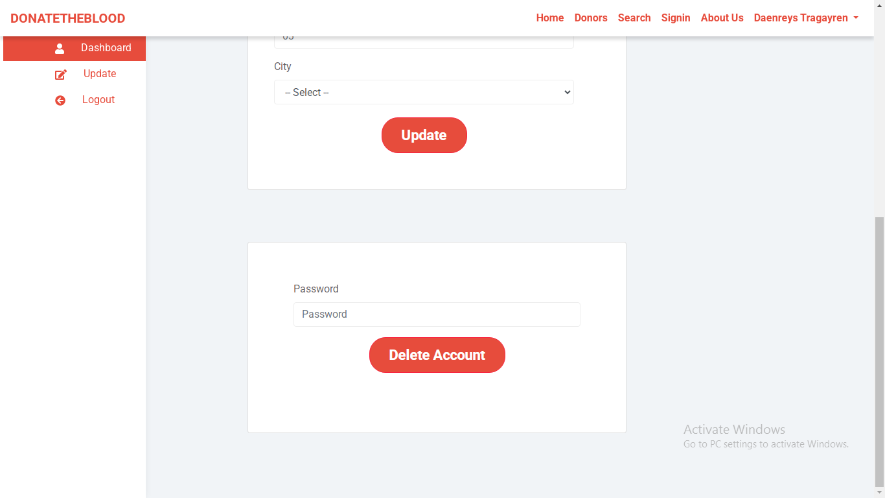

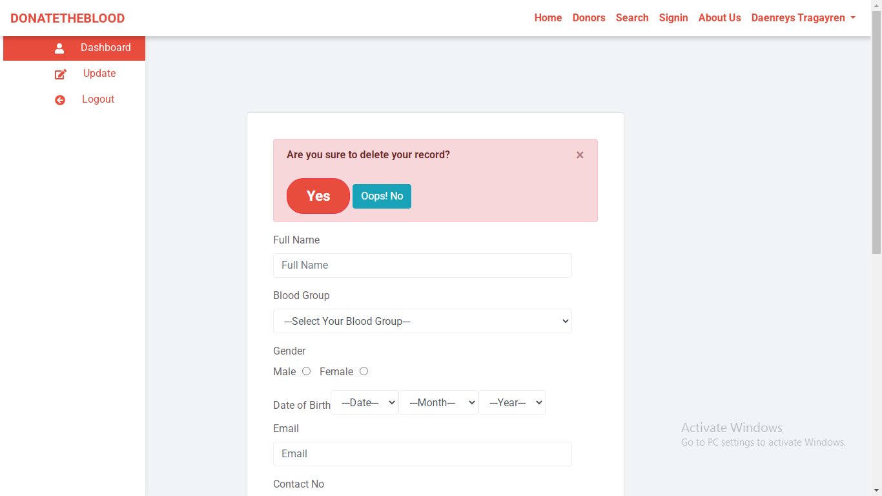

Notification Module
- Verified that donors receive reminders when they are eligible to donate again.
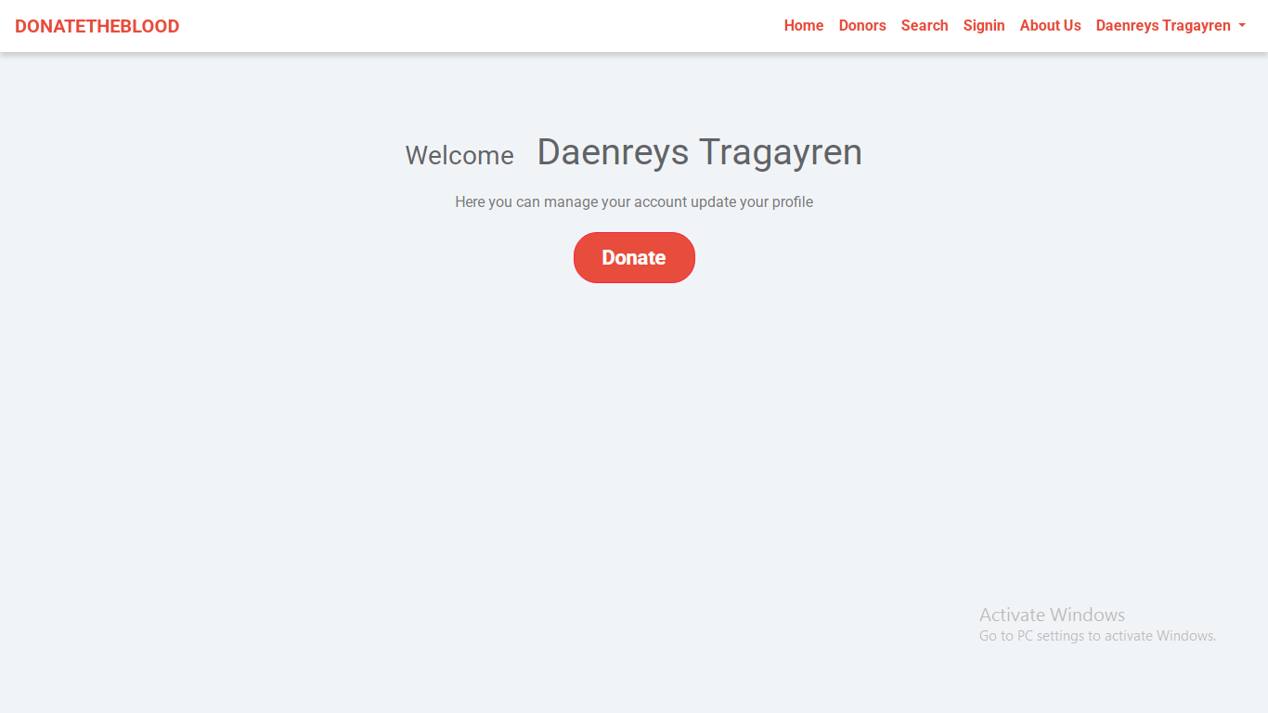

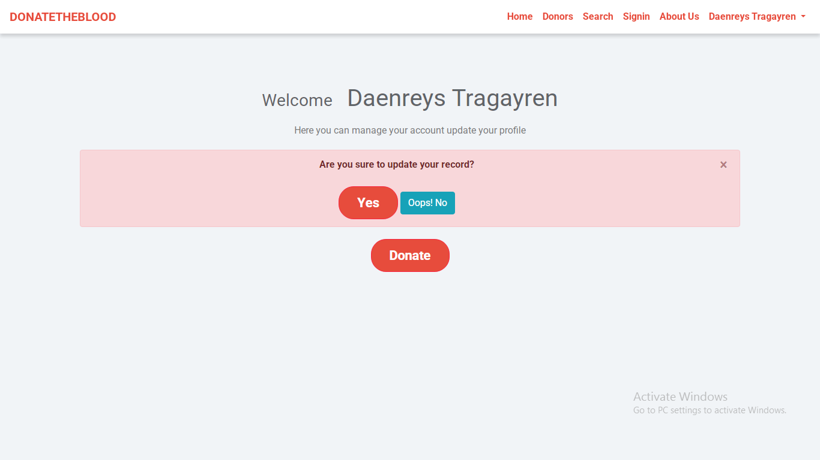

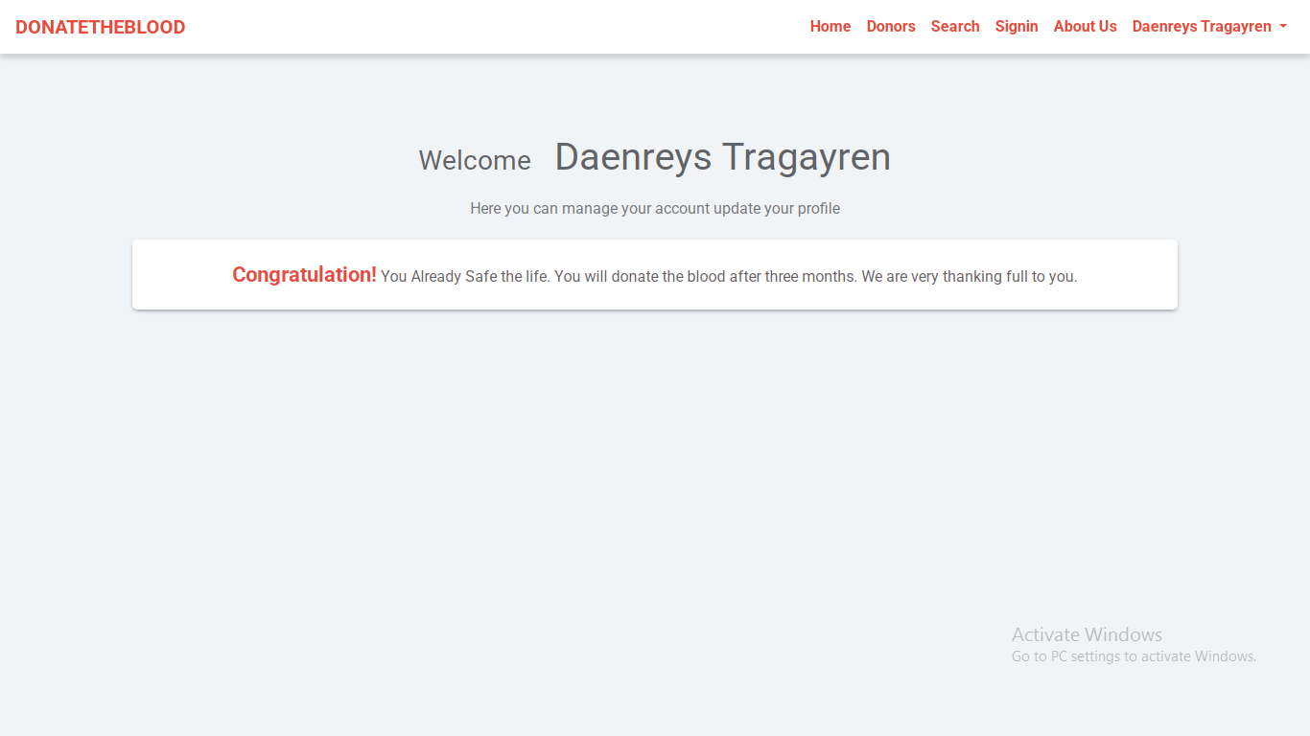

8. Test Cases

- User Registration & Authentication Module
Test Case ID | Test Scenario | Input Data | Expected Output | Status
TC-01 | Register a new user with valid details | Name, Email, Password, Blood Group, State | User account created successfully | Pass
TC-02 | Register with an existing email | Existing Email | Error message: "Email already exists" | Pass
TC-03 | Register with missing fields | Empty Fields | Error message: "All fields are required" | Pass
TC-04 | Login with correct credentials | Valid Email & Password | User redirected to dashboard | Pass

- Patient Management Modules
Test Case ID | Test Scenario | Input Data | Expected Output | Status
TC-07 | Donor registers successfully | Name, Blood Group, Location, Contact | Donor added to database | Pass
TC-08 | Update donor profile | Modify contact info | Profile updated successfully | Pass
TC-09 | Delete donor account | Click on delete | Account removed from database | Pass
TC-10 | Search for donors by blood group | Select "O+" | List of O+ donors displayed | Pass
TC-11 | Search for donors by location | Select "Delhi" | List of donors from Delhi displayed | Pass

- Blood Donor Search Module
Test Case ID | Test Scenario | Input Data | Expected Output | Status
TC-12 | Search with valid blood group and state | A+, Maharashtra | List of A+ donors in Maharashtra | Pass
TC-13 | Search with missing fields | Only blood group selected | Error: "Please select both fields" | Pass
TC-14 | No matching donors available | AB-, Nagaland | Message: "No donors found" | Pass

- Profile Management Module
Test Case ID | Test Scenario | Input Data | Expected Output | Status
TC-15 | Update user profile | Change phone number | Profile updated successfully | Pass
TC-16 | Delete user account | Click delete | Account removed permanently | Pass

- Notification Module
Test Case ID | Test Scenario | Input Data | Expected Output | Status
TC-17 | Send donation reminders | Donor eligible after 3 months | Reminder notification sent | Pass

9. Future Scope
- Mobile Application Development – Expanding the system into a mobile app for easier donor registration and real-time notifications.
- AI-Based Donor Matching – Implementing smart algorithms to suggest the nearest and most suitable donors based on availability and past donation history.
- Real-Time Blood Availability Tracking – Integrating with hospitals and blood banks to provide live updates on available blood units.
- Automated Donation Reminders – Enhancing the notification system to automatically remind donors when they become eligible again.
- Multi-Language Support – Adding regional language options to make the system more accessible to a larger audience.
- Integration with Healthcare Systems – Connecting with hospital databases to ensure faster and more accurate donor-recipient matching.
- Emergency Request Feature – Implementing an urgent request button to notify nearby donors instantly in case of emergencies.

Conclusion
The Blood Bank Management System provides an effective solution for managing blood donor information and connecting recipients with available donors. By allowing users to register, search for donors, update profiles, and receive donation reminders, the system ensures a quick and reliable process for blood donation.
Through secure authentication, real-time donor search, and automated notifications, the platform enhances efficiency, accessibility, and user engagement. Future improvements such as mobile app integration, AI-based donor matching, and hospital collaborations can further enhance the system, making blood donation more accessible and organized. This system plays a vital role in saving lives by ensuring timely blood availability.

Reference

Books & Journals
- Jacob, S., & Kumar, R. (2018). Blood Bank Management Systems: Concepts and Implementation. Springer.
- Singh, A., & Mehta, P. (2021). Healthcare Information Systems and Blood Donation Management. CRC Press.

Research Papers
- Sharma, V., & Patel, A. (2020). Optimizing Blood Bank Management Systems Using Digital Technology. International Journal of Healthcare Technology.
- Ramesh, B., & Gupta, M. (2019). Challenges and Advancements in Online Blood Donation Systems. Journal of Medical Informatics.

Web Resources
- World Health Organization (WHO) – www.who.int
- National Blood Transfusion Council (NBTC), India – www.naco.gov.in/nbtc
- American Red Cross Blood Donation – www.redcrossblood.org
- ResearchGate – www.researchgate.net

